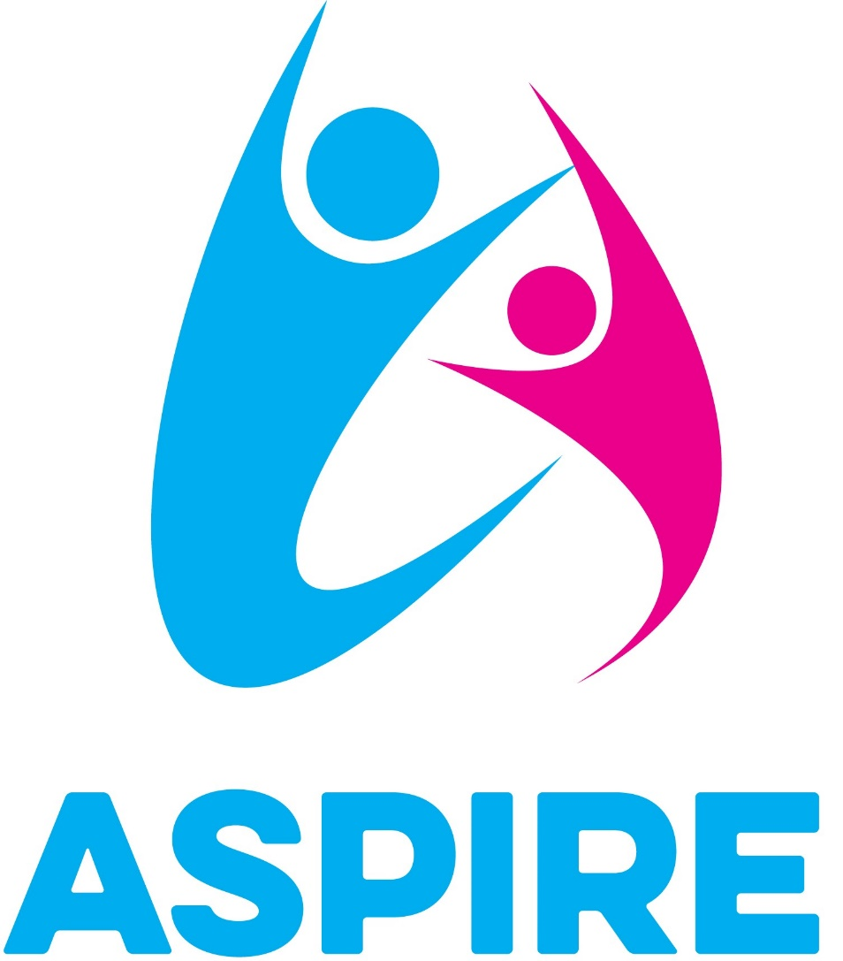
THE ASPIRE HUB
COVID- 19

Information around returning to the workplace.
CORONA VIRUS (COVD-19)
There are important actions that children and young people, their parents and those who work with them can take during the coronavirus outbreak, to help prevent the spread of the virus.
In all education, childcare and social care settings, preventing the spread of coronavirus involves dealing with direct transmission (for instance, when in close contact with those sneezing and coughing) and indirect transmission (via touching contaminated surfaces). A range of approaches and actions should be employed to do this. These can be seen as a hierarchy of controls that, when implemented, creates an inherently safer system, where the risk of transmission of infection is substantially reduced. These include:
- Minimising contact with individuals who are unwell by ensuring that those who have coronavirus symptoms, or who have someone in their household who does, do not attend childcare settings, schools or colleges
- To do this The Aspire Hub will require to record daily information and to take temperatures of staff and children prior to entering the building or accessing Aspire Transport. Anyone exhibiting a high temperature or symptoms relating to corona virus will be advised they are unable to attend in line with government guidance

- Cleaning hands more often than usual - wash hands thoroughly for 20 seconds with running water and soap and dry them thoroughly or use alcohol hand rub or sanitiser ensuring that all parts of the hands are covered
- The Aspire Hub will implement good hygiene procedures including regular hand washing
and throughout the day hand sanitiser, moisturiser and barrier cream will be used,
staff and children will use gloves for washing pots, staff and children will wear one set of aprons and tabards for food prep and a different set for craft/ art activities.

- Ensuring good respiratory hygiene - promote the ‘catch it, bin it, kill it’ approach
- To promote the ‘catch it, bin it, kill it’ approach all staff and children will be encouraged to
use paper towels to dry hands after washing and discard in the bin.

- Cleaning frequently touched surfaces often using standard products, such as detergents and bleach
  - The Aspire Hub will ensure regular wiping of surfaces throughout the day. At the end of each day the large furnishing will be cleaned and disinfected.

- Minimising contact and mixing by altering, as much as possible, the environment (such as classroom layout) and timetables (such as staggered break times)
- The Aspire Hub will identify Individual risk assessments for children highlighting the need for physical intervention. Where possible children will work outside and where possible social distancing measures will be implemented.

- Personal protective equipment (PPE) including face coverings and face masks
Wearing a face covering or face mask in schools or other education settings is not recommended. Face coverings may be beneficial for short periods indoors where there is a risk of close social contact with people you do not usually meet and where social distancing and other measures cannot be maintained for example on public transport or in some shops. This does not apply to schools or other education settings. Schools and other education or childcare settings should therefore not require staff, children and learners to wear face coverings
- At the Aspire Hub social distancing measures are not always possible.
At times during the day children and staff will need to be in close proximity,
during these times staff will be required to wear face coverings to prevent the risk spreading germs.

- Children, young people, and students whose care routinely already involves the use of PPE due to their intimate care needs should continue to receive their care in the same way
- If a child, young person or other learner becomes unwell with symptoms of coronavirus while in their setting and needs direct personal care until they can return home. A face mask should be worn by the supervising adult if a distance of 2 metres cannot be maintained. If contact with the child or young person is necessary, then gloves, an apron and a face mask should be worn by the supervising adult. If a risk assessment determines that there is a risk of splashing to the eyes, for example from coughing, spitting, or vomiting, then eye protection should also be worn
- At the Aspire hub where a risk assessment would identify that a child may display any of the above staff will be provided with eye protection.

Aspire action Plan highlighted in bold and is in conjunction with government guidance January 2021. We will revisit and review this advice when the science and government indicate to do so.

Procedures in place to ensure the protection of staff and children

Start of the day
All children and staff to have temperature taken and the below questions asked prior to being transported to the hub or entering the building. This will be recorded daily.

Staff initial | Date | Are you exhibiting any signs of the virus? | Is there someone at home exhibiting signs of the virus? | Temp  AM | Temp  PM | Do you require Emotional support? | Signature

Child  Initial | Date | Is your child exhibiting any signs of the virus? | Is there someone at home exhibiting any signs the virus? | Temp  AM | Temp  PM | Do you require additional support? | Parent Signature

- Identified member of staff will take temperatures of all children and staff will take their own temperature and record it on the signing in and out sheet. Whilst temperatures are being taken staff need to be aware of social distancing. Temperatures will be taken with a non- contact thermometer.
- Anyone with a high temperature above 37.8C or any corona virus symptoms are to be refused access to the building, staff are to contact the hub and speak to your line manager each day to monitor the symptoms. You must follow the government guidelines of 10 days isolation. If anyone in your household is showing any symptoms you must self-isolate for 10days. Before returning to work staff members are to have tested negative for corona virus.
- Children being transported to and from the Hub on the minibus will be allocated their own seat and a reduced number of children will be on the mini- bus to keep with the social distancing guidelines. Staff will be wearing face coverings and eye protection if needed along with the Hi Vis vest.
- Upon entering the building staff will hang coats in the staff room
- Children will hang outdoor coats and remove shoes.
- Staff will wash hands and have relevant PPE prior to entering the classroom.
- Bolton site- children who arrive off the minibus will enter the building via the shutter door, a staff member will come to collect the children from the bus and escort to the classroom. The children will be escorted at staggered times.
- Parents who bring their child to the Burnley and Bolton Hub a staff member will meet you and ask the above information and take temperature of the child and escort the child into the hub. This is to minimise the amount of people accessing the Hub.

Throughout the Day
- Communal areas will be restricted to a maximum of two to three staff members at one time depending on white Hub you are at.
- All staff and children to wash hands thoroughly during transition times and to dry hands with paper towels and dispose in the bin.
- Hand sanitiser is to be used in between hand washing
- Entering the classroom staff are to wear tabards and appropriate PPE
- During times of close proximity or 1-1 staff are advised to wear a face covering.
- Staff and children are to social distance where possible
- Regular wiping of surfaces
- All children needs will be identified through passport and risk assessment and in crisis staff would, where appropriately have a change of face with someone wearing PPE.
- Where staff feel the need to wear appropriate PPE as a precautionary measure, they will have access to PPE.
- Throughout the day staff to follow the new behaviour policy procedures and limit holding where possible. Use the reflection room to minimise the need for positive handling. Staff are to wash hands straight away after positive handling, wear visors / PPE and change face at the earliest opportunity with a staff member wearing PPE.

End of the day
- Record staff and children temperatures prior to finishing for the day
- Children will be escorted to the bus at staggered times
- Children are escorted to their parents by a staff member and have the temperature recorded.
- Cleaning of the hub -To reduce to numbers of people accessing the hub staff will need to take on cleaning duties
- Surfaces will be wiped, and antibacterial spray used
- Aprons/ masked will be washed and dried every day
- Tea towels and clothes washed daily
- Floors mopped chairs and tables cleaned /wiped using antibacterial `
- Reading chairs and sofas sprayed with antibacterial daily
- Any soft furnishings or blankets used must be changed daily and washed

Date | Ratification | Reviewed by
May 2020 | This policy was ratified by the board of Directors | Directors
Jan 2021 | Reviewed – changes made to reflect new guidance | Lauren Bullock Gillian Bullock Jennifer Jackson Linda Wyld Jade Wyld Louise English

